

BIOMETRIC VEHICLE ACCESS

SP17- Human Computer Interaction

Under esteemed guidance by:

Prof. Keith Bagley.

Project By: Sneha Palvai



**EXECUTIVE SUMMARY**

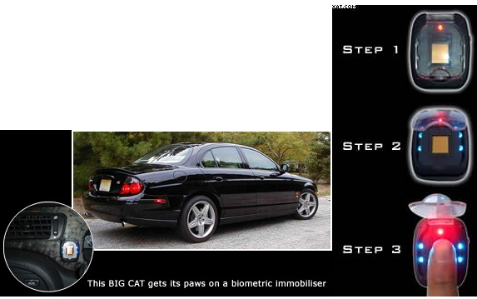

The main aim of this project is to help users secure their car and also enjoy the pleasure offered by with the help of Biometric access. The idea is to provide security features for our car using fingerprint. It also prevents car theft. The uniqueness lies in providing secure authentication facility for cars. Further discussed are few exciting features about this project.

Here a scanner is held on the door or dashboard whereas the user will be able to access his car without any handheld external keys. It is much easier for the users like me who always forgets their key at his/her apartment and gets down to parking without keys. At this point of time, I personally will be so happy to save time by using my own fingerprint as my access key to open the car door and start my car. In addition to that, I will be working on few interesting features like providing automatic seat belt on/off facilities, fixing mini refrigerator which can be accessed through biometric access, providing feature to secure any important documents in car. It can also synchronize with user’s mobile phone and can locate the parking lot of his/her car.

**TABLE OF CONTENTS**

Existing system and its Problems

Proposed system

Design Approach

Principles

Scenario

Storyboard Sketching

Advantages

Problems/Inhibitors

Conclusion

Lessons Learnt

**EXISTING SYSTEM**:

Now-a-days, everyone uses an external key in order to lock/unlock their cars. Based on considering the factor of reducing the usage of external usage of key and implementing biometric access to lock/unlock car door and also facilitates keyless start engine.

**PROBLEM STATEMENT IN EXISTING SYSTEM:**

Though there are few advantages in this existing there are few things that really bother user while suing this biometric only to open/close door. User was not happy to buy this type only to lock/unlock or start car. User cannot view history on who might have entered this car. User expects more things to be concentrated in order to achieve high success for this product.

**PROPOSED HCI DESIGN SYSTEM:**

Considering these requirements from user’s end, I have decided to add more additional interesting features which attracts user to buy my “BIOMETRIC VEHICLE ACCESS” car. It reduces the external hardware, by adapting those features through fingerprint sensor. It is a very good improvement for automobile industry as it provides the best design with simple infrastructure and user interface.

Major requirements for this finger print sensing product to be launched in a successful way by the company are:

1. Mechanical design of sensing pad
2. Controller Integrated chip
3. Algorithms running for IC.

There are 3 types of sensing pads capacitive fingerprint, optical fingerprint and ultrasonic fingerprint. Here the designers mostly consider ultra-thin fingerprint as it helps them to select their own choice of appearance of hardware used anywhere in cars.

DESIGN APPROACH:

Initially, I have considered Hierarchical Task analysis in order to expect the things the user would do and focused on how can the user use my product?

TEXTUAL HIERARCHICAL TEXTUAL ANALYSIS (HTA) DESCRIPTION:

1. In order to use my fingerprint access featured car.
2. The user has to buy a biometric car and register with their name.
3. Give his fingerprints to access.
4. Synchronize his car access to his mobile phone.
5. By using his touch access, detect his vehicle parking location
   1. Start keyless engine
   2. Fix his/kid’s seatbelt
   3. Save his important documents
   4. Grab drinks/food by giving access to mini refrigerator in his car
6. Reach the destination and Stop the engine.
7. Detach seatbelts, place car in a proper parking lot and close the car door.

Plan 0: Do 0-1-2-3-4 until the destination is reached and then do 6.

Plan 4: Do 4.1-4.2 in an order and then depending upon user requirements he can do either 4.3 or 4.4

I have chosen Textual HTA description as it is easily and clearly understood by everyone.

PRINCIPLES USED AND REASONS BEHIND CHOOSING THEM:

I have taken into account of few of the universal design principles while designing my product. They are:

Flexibility in use: I have designed a finger print touch access in a way that is very flexible to use by the users. For example, user can easily use his open/close door to access which is very flexible for him.

Low physical effort: Considering this principle, I have decided to design my project such that user has to put minimum physical effort in using my product. Such as user need not use his external keys and struggle to open the door or start engine. He can just do it by his touch access.

Tolerance for error: My product has no chances of occurrences of errors and malfunctions. For example, an unauthorized person cannot enter his car without the owner’s permission and also the cars functions perfectly fine without any errors.

Size and space: Based on user’s convenience, I have designed my product to be so simple and precise in a limited space such that it doesn’t occupy much space. I have chosen the design should be small spherical in shape.

Internal locus of control: With the help of biometric access and the inbuilt software easily facilitates internal control of car by user’s access.

I have considered one scenario, in order to clearly explain how the user can use my product easily in a flexible way.

**SCENARIO:**

Kate has two 5 year old kids. In his busy schedule, Kate has to drop his kids at Kindergarten and has to rush to his office. He detects car parking spot from his mobile which was synchronized from his car. If he has a car with finger touch access, he can automatically open door, START his keyless engine and locks/unlocks seatbelt of his own and kids and can grab some juice or water from his mini storage refrigerator opening with his biometric metric. He added his family members for access. He dropped kids and then finally reach his office making his life move in a comfortable manner.

**STORY BOARD SKETCHING**

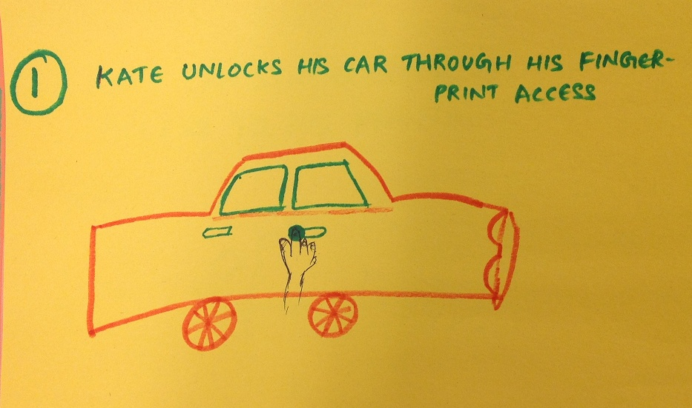

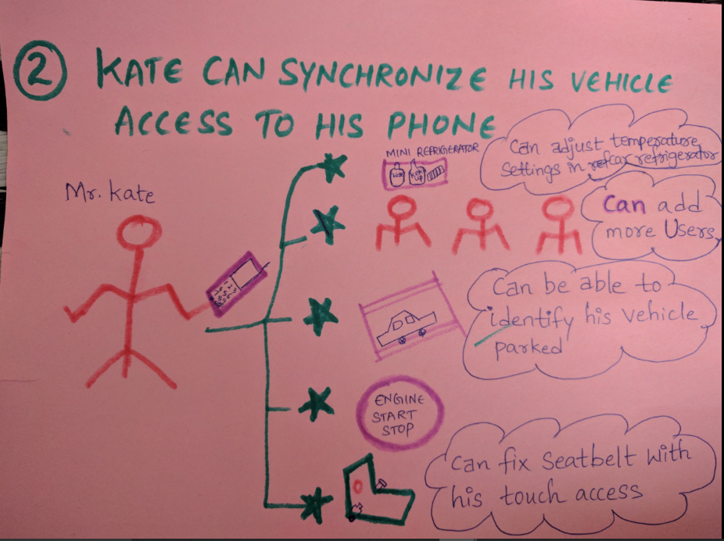

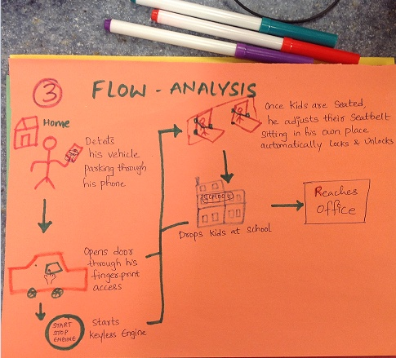

**ADVANTAGES OF PROPOSED SYSTEM:**

* Facilitates lock/unlock car door.
* Keyless engine start/stop
* Viewing history of people who entered car
* Adding more users (family members) and synchronized with mobile phone to send a reminder where the car is parked?
* Securing important documents or wallets in a cabin by adding biometric fingerprint access which would be really helpful especially travelling with strangers in your personal car during some trips.
* To enable fingerprint touch button at the side of seat so that the seat belt is automatically adjusted without even using our hands and gives a message from a speaker in order to give us confirmation. This can be more useful for kids to use themselves. If not, the parent can directly press the automatic access for their kids once they are seated. I really feel this as the important unique feature as every person needs this and it saves little time which is a great relaxation for user not using his hands and adjust seatbelt physically.

**PROBLEMS AND REASONS BEHIND NOT GOING SUFFICIENTLY WELL:**

My project is mostly useful for professional working middle class and upper-class people as its quite expensive when compared to other normal cars. I would rather say most of the teenagers show interest towards these model cars. My first priority goes to teenagers and IT working professionals as they can easily understand technical terms and try to use them. This wouldn’t be so useful to lower-class users as they cannot afford this car. In addition to that older people do not make an attempt to use this features as it is little difficult for them to adapt latest technology soon though it has simpler functionalities as they are satisfied and feel comfortable with their own personal car which they are used to.

This car can more purchased in highly advanced countries like USA, Australia, china, Germany etc. as car plays a major role in their survival and people here are more likely to adapt using new technical features easily. People here are most educated and will be able to understand any technical terminology easily. As they lead a busy life, they try to save their time by using sensing techniques to open/close door, start engine instead of using an external key to open/close. Moderate countries cannot afford this car which is a major issue in bringing this project successful. It cannot be successful in all the countries.

**NEW THINGS LEARNT FROM THIS PROJECT:**

* I really enjoyed my HCI project as it helped me to think mostly from user’s perspective.
* It helped me to watch interesting Shark Tank Episodes in order to know about VC Funding pitch.
* It helped me to research more work on user interface principles by which users can easily understand about it.
* In the persona and scenarios, it improved my imagination and creative skills.
* HCI is different from IT technology class. I loved it.

Here is my video link: <https://youtu.be/ua2T-jM_QJ0>